**SCREEN TEST**

MULTIPLE CHOICE, OBJECTIVE TYPE EXAMINATION SYSTEM FOR PC

GUIDE: GROUP MEMBERS:

RESHMA MISS AFEEFA SHIRIN

CCET, VALANCHERY AJMAL ROSHAN

BIBINA

BANEE ISHAQUE

MUFEEDA THESNI

**ABSTRACT**

Screen test is a windows software which can be useful for conducting objective type tests on various subjects (currently testing facility for 3 subjects is available, but we can extend it easily). Imagine that a screen test software is always available on your PC or Laptop. Then you can conduct objective type screen tests on various subjects; all are in just few seconds; this dream comes true with this windows software.

The software is protected by a login function. After successful login, you can perform the examination if you are in user role.If you are in admin role, then you can perform question manipulation (add, view, edit & delete questions). The main advantage of this software than the others is that wide range of users can use this software simply, because software is very user interfaced and in a clear-cut fashion.

**LIST OF FIGURES**

Figure 2.1 UI Elements

Figure 2.2 Swing menu Controls

Figure 3.1 Splash screen

Figure 3.2 Role selection page

Figure 3.3 User Login page

Figure 3.4 Subject selection page

Figure 3.5 Examination page

Figure 3.6 Examination page – after option selection

Figure 3.7 Examination page – Results

Figure 3.8 Examination page – result addition success message

Figure 3.9 Admin login page

Figure 3.10 Admin login page – error message

Figure 3.11 Admin page

Figure 3.12 Insert question page

Figure 3.13 Insert question page – success message

Figure 3.14 View question page

Figure 3.15 Edit question page

Figure 3.16 Edit question page – after success search

Figure 3.17 Edit question page – ready for submission

Figure 3.18 Delete question page

Figure 3.19 Delete question page - confirmation

Figure 3.20 View result page

Figure 3.21 Change password page

Figure 4.1 DFD for insert information to database

Figure 4.2 DFD for retrieve information from database

Figure 4.3 DFD for update information on database

**LIST OF TABLES**

Table 3.1 question bio

Table 3.2 user

Table 3.3 admin

**LIST OF ABBREVIATIONS**

OS Operating System

HOD Head of Department

DEPT Department

SRS Software Requirement Analysis

IEEE Institute of Electrical and Electronics Engineers

HDD Hard Disk Drive

GB Giga Byte

RAM Random Access Memory

IDE Integrated Development Environment

SQL Structured Query Language

PC Personnel Computer

XP Extreme Programming

GUI Graphical User Interface

API Application Programming Interface

AWT Abstract Window Toolkit

UI User Interface

GWT Google Web Toolkit

RDBMS Relational Database Management System

GNU GNU’S Not Unix

FIGURE Figure

DFD Data Flow Diagram

DB Database

**INTRODUCTION**

The Screen test has been developed for conducting objective type tests on various subjects (currently testing facility for 3 subjects is available, but we can extend it easily). You can conduct objective type tests on various subjects in just few seconds. Basically Screen test is a utility software for windows platform.

**View Information:** User can view properly arranged information.

**Add Information:** Administrative user can insert new information to database.

**EXISTING SYSTEM**

Existing system used in OMR valuation like PSC Exams. For this, we use papers. Handling of papers will be difficult. Also for OMR valuation we use barcodes. For reading this barcode, we need OMR scanners. This will make extra expenses.

**PROPOSED METHODOLOGY**

**i)Procedure-**

Our software SCREENTEST have two types of users.

1)Admin 2)Student

Admin handles question management like insertion, deletion and updation.

Students are participating the examination after authentication.

**ii)Module-**

1)Administration Module-

1.1- Question Management

1.2- Insert Question

1.3- Delete Question

1.4- View Question

1.5- Edit Question

2)Student Module-

2.1- Start Exam

**iii) Algorithm-**

1. **Login-**
2. Start
3. Inputs are username and password
4. Check username and password
5. If found login
6. Otherwise display error
7. Stop
8. **View Exam-**
9. Start
10. Retrieve exam from database
11. Display exam
12. Stop
13. **View Question-**
14. Start
15. Input exam number
16. Retrieve question from database by matching exam number
17. Display questions
18. Stop
19. **Examination-**
20. Start
21. Invoke login
22. If login OK
23. Invoke view exams
24. Otherwise go to 16
25. Select an exam
26. Invoke view question details
27. Case skip: go to step 12
28. Case select option: if it is correct option
29. Increase mark
30. End if
31. Increase question count
32. If question count is over or time expired
33. Display mark
34. Otherwise go to step 7
35. Stop

**iv) DESIGN**

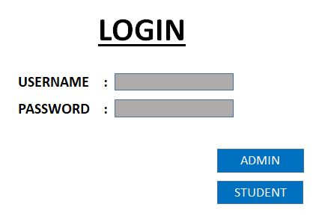

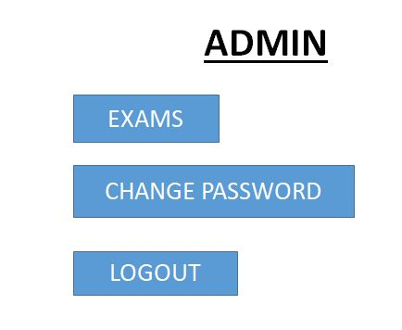

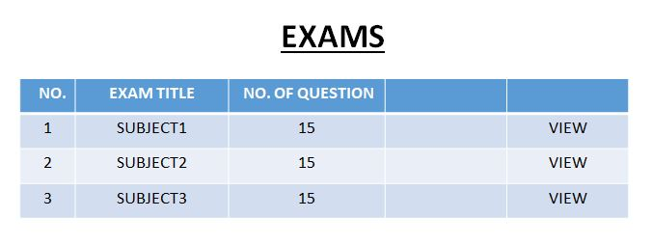

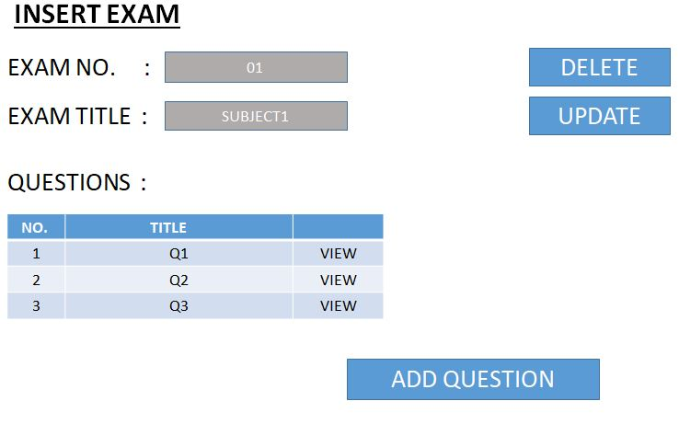

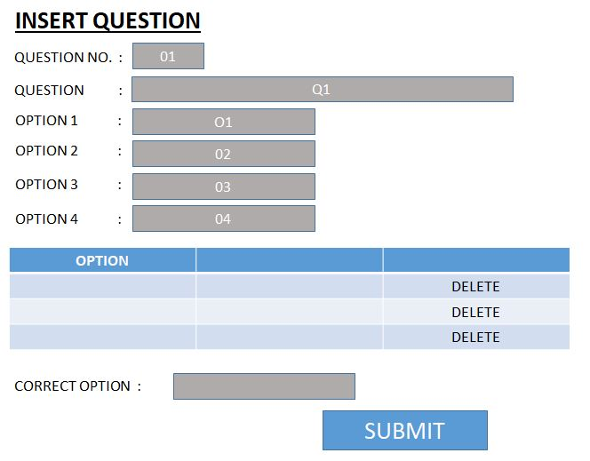

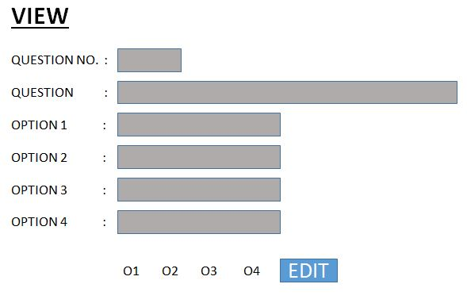

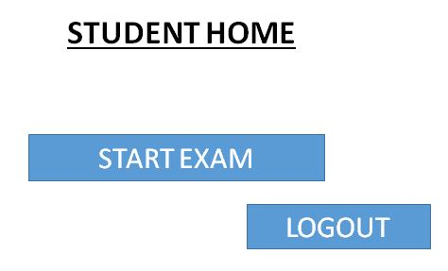

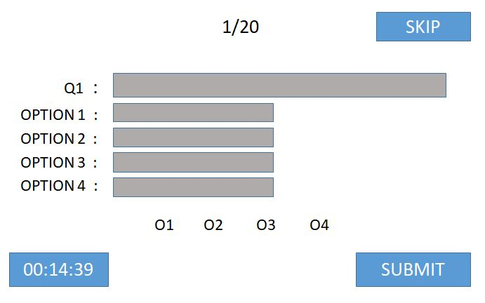

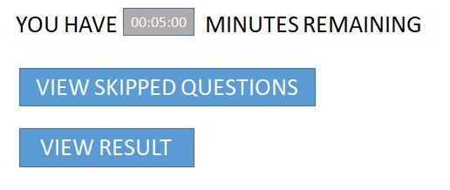

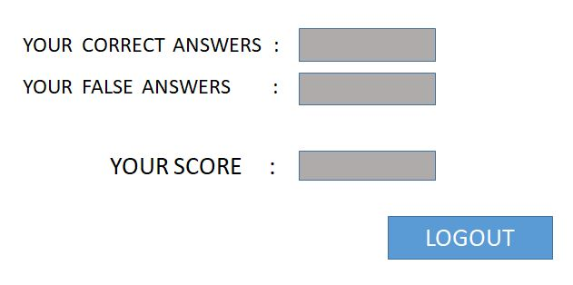

**DATABASE**

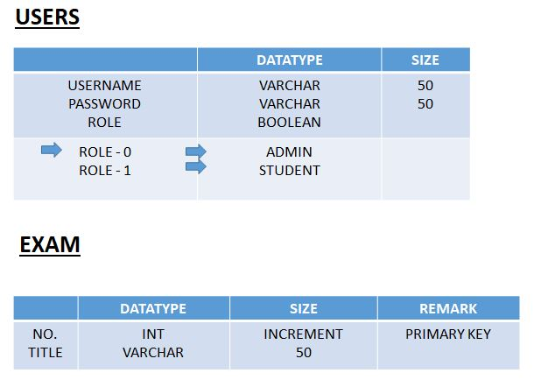

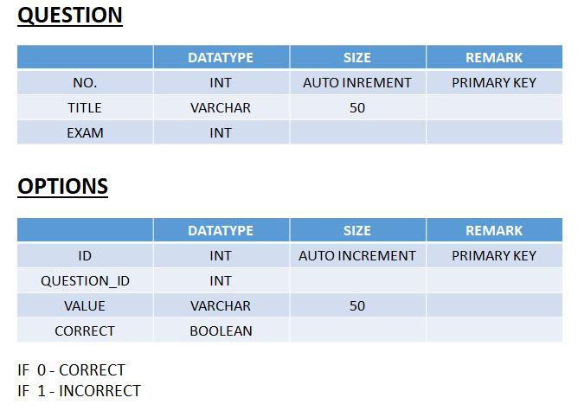

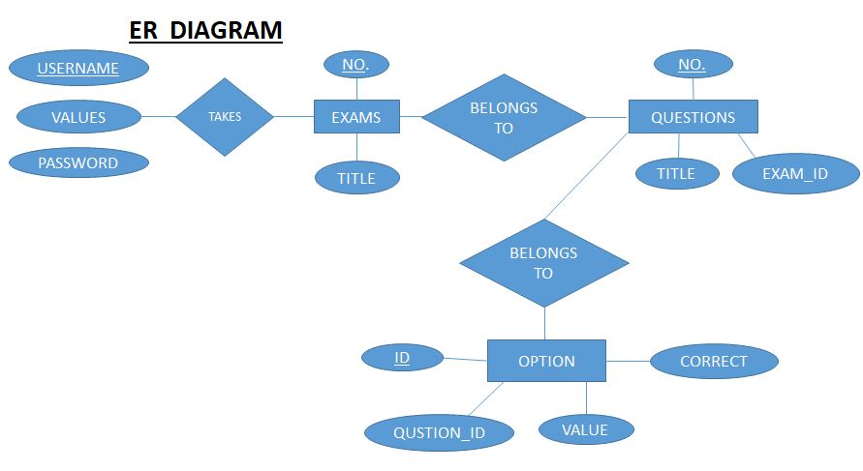

**DATA FLOW DIAGRAM**

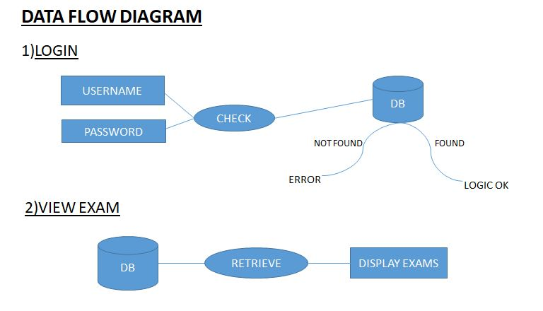

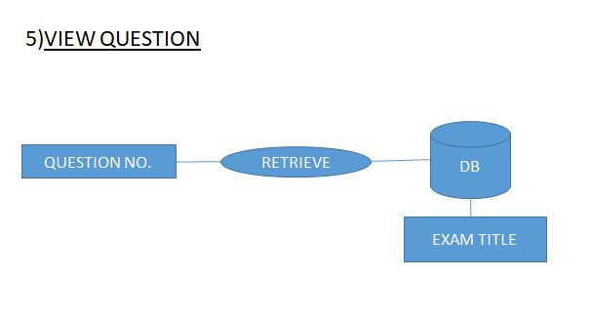

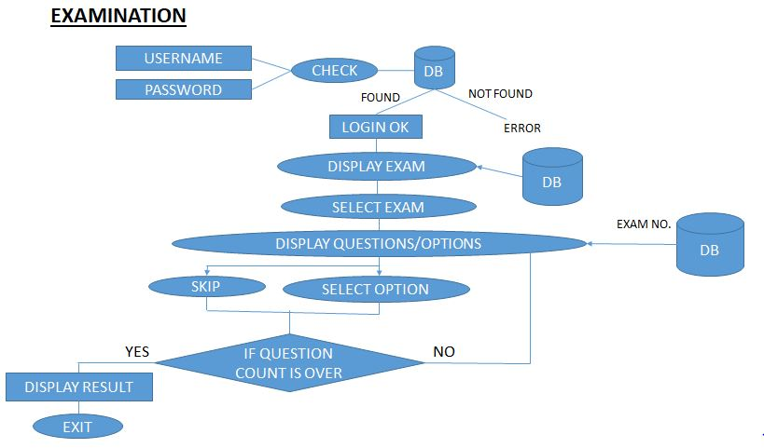

**V)SCREENSHOTS**

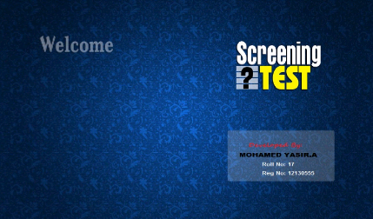

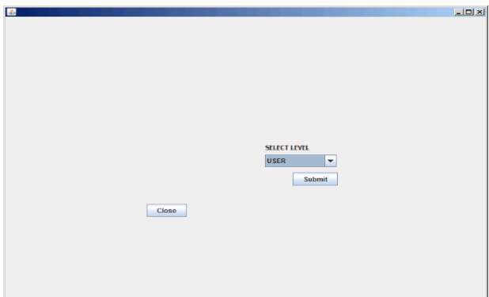

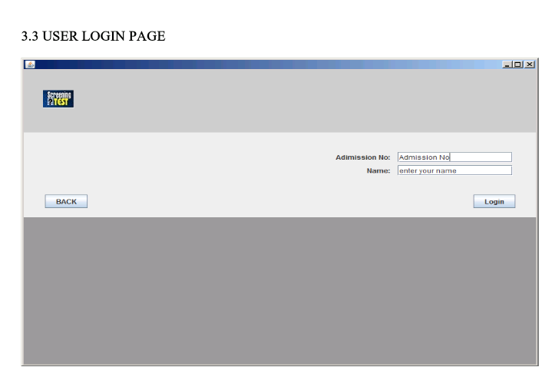

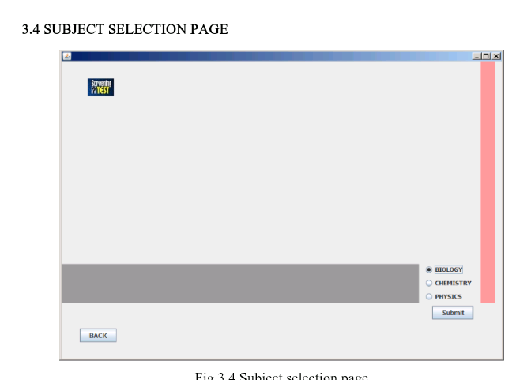

### 

### 

### 

### 

### 

**vi)ADVANTAGE**

The project could be implemented in any personal systems.

This system can be used by anyone with privileges. That is, to take examination or perform question manipulation; authentication is needed to control the malfunctioning of the software.

The main objective of the project is to help people who want to conduct objective type screen tests on various subjects.

It’s basically build in the platform of JAVA windows application which makes the application quite flexible and easy to be operated.

**CONCLUSION**

Objective of this work is to help people,who want to conduct & evaluate, multiple choice objective type screen tests, on various subjects.

This report is based on Screen test which help people to conduct objective type screen tests on various subjects. Some of the shortlist about it is given below and its future scopes:-

* An attempt is made in all its earnest towards the successful completion of the project. This system was verified with valid as well as with invalid data.
* This system is user friendly since it has been developed in NetBeans a successful GUI environment. Since the connection can be extended to any database. The control will be more powerful.
* Connecting it to any type of database extends the development control. Any suggestions for future development of the system are welcome.
* Upgrading the system if may can be done without affecting the proper functioning of system.
* It is very comfortable to use this, because it is very user friendly.
* This one in the Java Swing language so it is more wide and convenient for other developers to modify it.

**FUTURE ENHANCEMENTS**

Currently 3 options are available.

We can extend no. of options easily.

Also we can include varying no.of options.

Can extend to take

Multiple examinations with minimum reconfiguration.

**REFERENCES**

* Google, ‘http://www.google.co.in’
* Slideshare, ‘http://www.slideshare.net’
* Tutorials Point, ‘http://www.tutorialspoint.com’
* Oracle Docs, ‘http://www.docs.oracle.com’
* Dev.mysql, ‘http://www.dev.mysql.com’
* Wikipedia, ‘http://www.wikipedia.org’